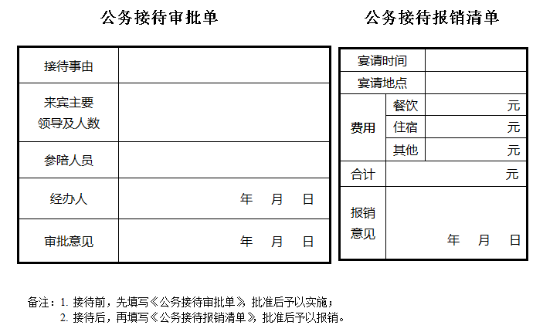
附件：
––––––––––––––––––––––––––––––––––

